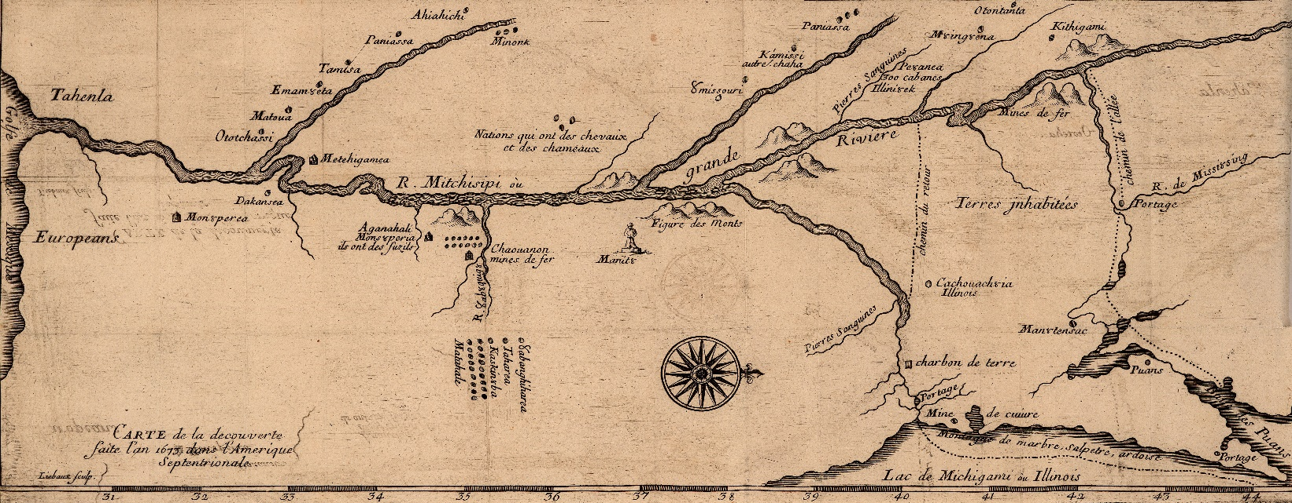

**Home Vita Publications Public Talks Consulting & Media Contact**

**Welcome!**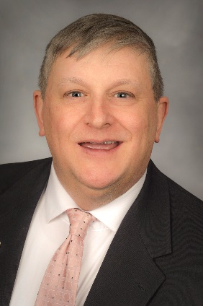

For the past three decades, I have pursued the study of history as a researcher, author, and university instructor. Currently, I serve as a professor of history and anthropology at the Milwaukee School of Engineering in Milwaukee, Wisconsin.

I have a wide range of interests: American history, art history, North American Indian cultures, the history of the Midwest, the Second World War…the list goes on.

More than anything, I enjoy sharing my interests with the general public. So much of what we read and hear about the dramatic story of the human past is superficial and shallow. I enjoy engaging in topics that are deep, thoughtful, and at times unsettling.

Please look through my webpage to see the kinds of research I have done and the topics on which I like to speak. Contact me if you are interested in booking me for a talk for your historical society or civic organization.

I am also an experienced historical researcher who enjoys working as a consultant. Let me know if you have an opportunity we can pursue together.

Visit the link to my publications if you are interested in any of the books or articles I have written. The articles can be downloaded at no cost.

My contact information is below. You can also click here to email me.

I look forward to hearing from you!

Dr. Patrick J. Jung

Milwaukee School of Engineering

1025 North Broadway

Milwaukee, Wis. 53202-3109

Phone: 414-277-7257

Email: jung@msoe.edu